create table emp12(emp_id numeric , firstname varchar(35),lastname varchar(35),salary numeric);

create table bonuses(emp_id numeric,bonus numeric);

INSERT INTO emp12 VALUES(101,'Stefan','Salvatore',90000);

INSERT INTO emp12 VALUES(102,'Caroline','Forbes',80000);

INSERT INTO emp12 VALUES(103,'Elena','Gilbert',40000);

INSERT INTO emp12 VALUES(104,'Katherine','Pierce',70000);

INSERT INTO emp12 VALUES(105,'Bonnie','Bennet',50000);

INSERT INTO bonuses VALUES(101,0);

INSERT INTO bonuses VALUES(102,0);

INSERT INTO bonuses VALUES(103,0);

INSERT INTO bonuses VALUES(104,0);

INSERT INTO bonuses VALUES(105,0);

**MERGE Usage and Syntax :**

MERGE INTO bonuses b

USING emp12 e

ON (b.emp_id = e.emp_id)

WHEN MATCHED THEN

UPDATE SET b.bonus = e.salary * .05;

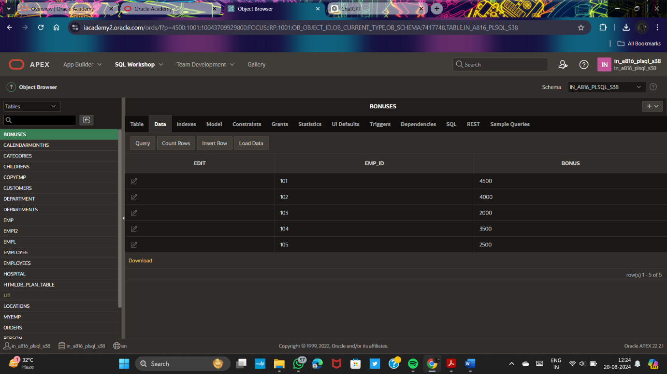

DECLARE

v_emp_lname myemp.lastname%TYPE;

BEGIN

SELECT lastname

INTO v_emp_lname

FROM myemp

WHERE employee_id = 106;

DBMS_OUTPUT.PUT_LINE('His last name is ' || v_emp_lname);

END;

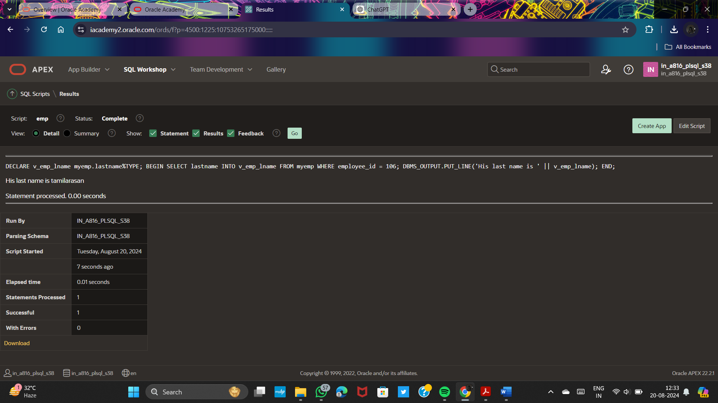

DECLARE

v_emp_lname employee.lastName%TYPE;

v_emp_salary employee.salary%TYPE;

BEGIN

SELECT lastName, salary

INTO v_emp_lname, v_emp_salary

FROM employee

WHERE department_id = 80;

DBMS_OUTPUT.PUT_LINE('Last name: ' || v_emp_lname);

DBMS_OUTPUT.PUT_LINE('Salary: '|| v_emp_salary);

END; 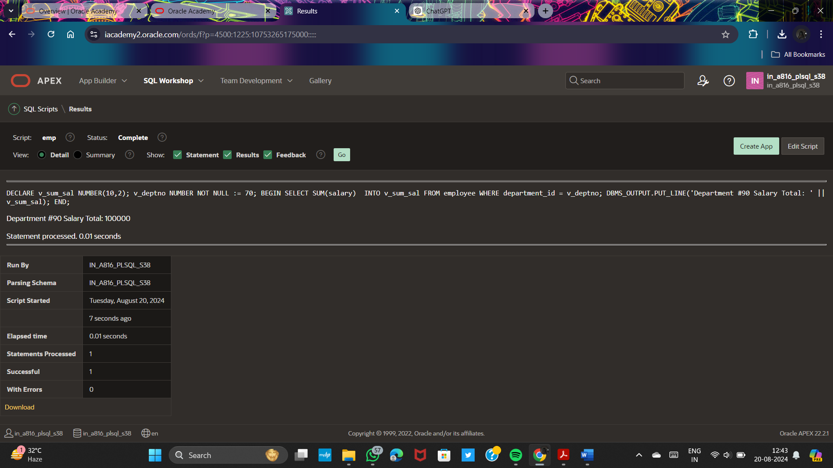

DECLARE

v_sum_sal NUMBER(10,2);

v_deptno NUMBER NOT NULL := 70;

BEGIN

SELECT SUM(salary)

INTO v_sum_sal FROM employee

WHERE department_id = v_deptno;

DBMS_OUTPUT.PUT_LINE('Department #90 Salary Total: ' || v_sum_sal);

END;

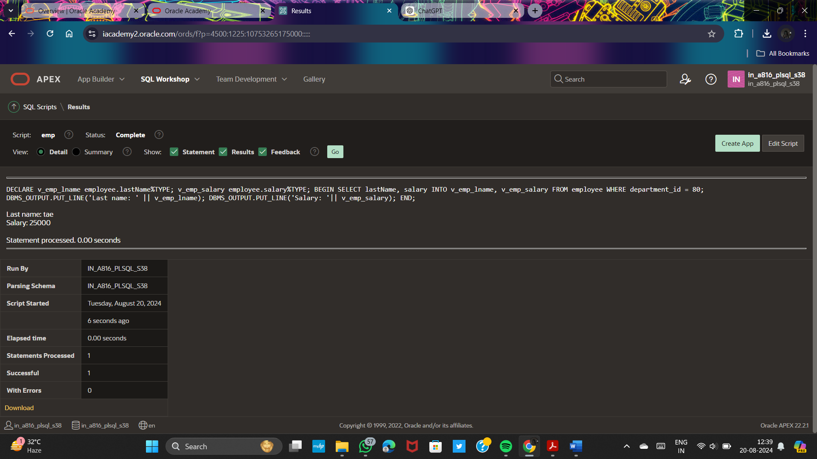

**PLSQL_3_3:**

**Inserting Data:-**

BEGIN

INSERT INTO copyemp(employee_id, firstname, lastname, deptid)

VALUES (200, 'Ruth', 'Cores',6);

END;

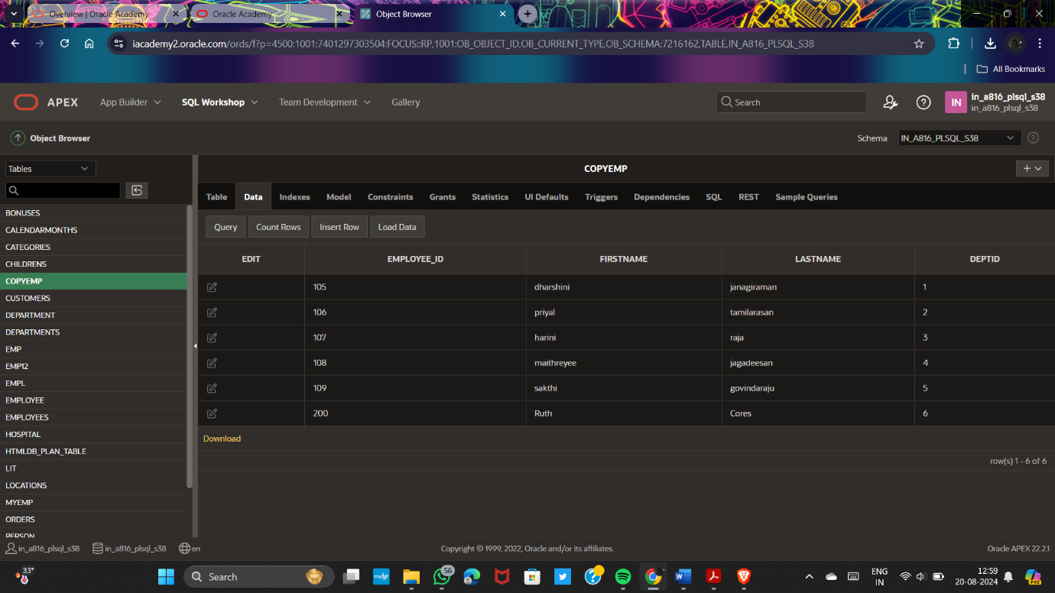

**Deleting Data:-**

DECLARE

v_deptno copyemp.deptid%TYPE := 6;

BEGIN

DELETE FROM copyemp

WHERE deptid = v_deptno;

END;

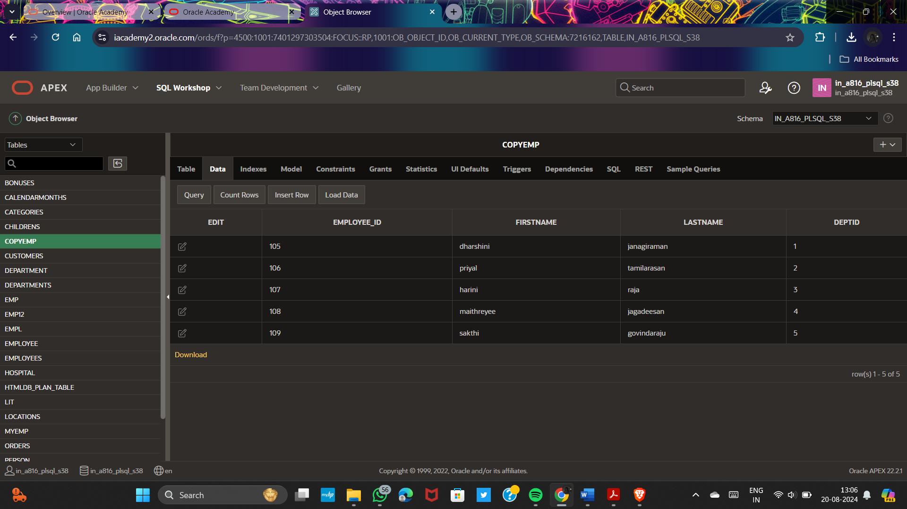

**Merging Rows:**

BEGIN

MERGE INTO copyemp c

USING myemp e

ON (e.employee_id = c.employee_id)

WHEN MATCHED THEN

UPDATE SET

c.firstname = e.firstname,

c.lastname = e.lastname,

c.deptid = e.deptid

WHEN NOT MATCHED THEN

INSERT (c.employee_id, c.firstname, c.lastname, c.deptid)

VALUES (e.employee_id, e.firstname, e.lastname, e.deptid);

END;

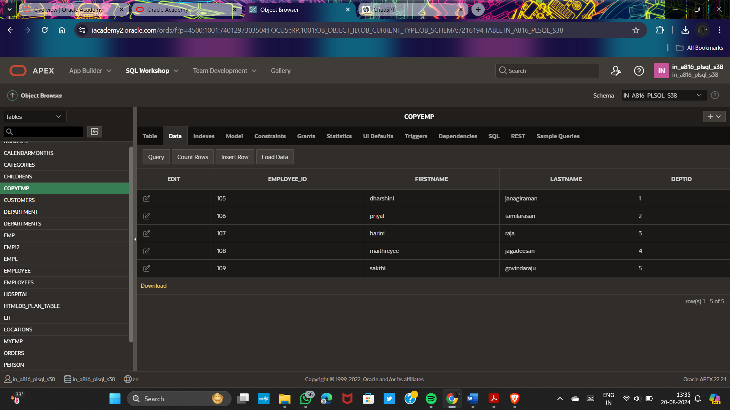

**Using Implicit Cursor Attributes: Good Practice Guideline:**

DECLARE

v_rowcount INTEGER;

BEGIN

UPDATE employees

SET salary = salary + 100

WHERE departmentid = 1;

DBMS_OUTPUT.PUT_LINE(SQL%ROWCOUNT || ' rows in employeesupdated.');

v_rowcount := SQL%ROWCOUNT;

INSERT INTO results (num_rows)

VALUES (v_rowcount);

DBMS_OUTPUT.PUT_LINE(SQL%ROWCOUNT || ' rows in RESULTS updated.');

END;

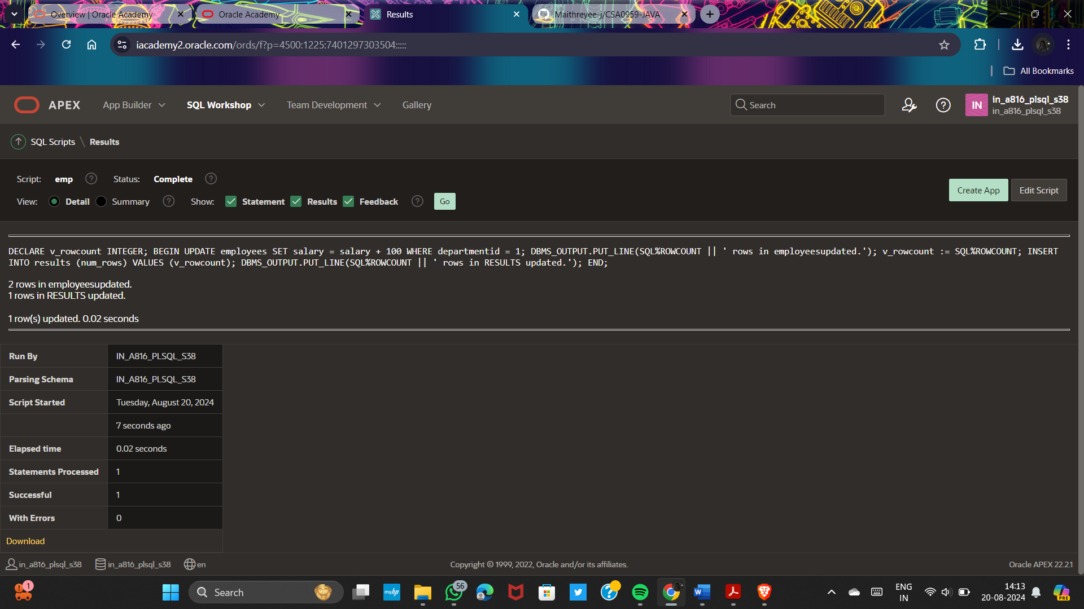

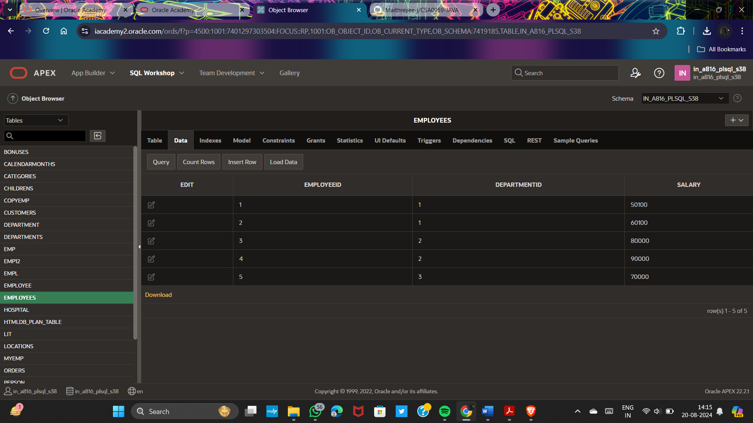

DECLARE

CURSOR c_emp_cursor IS

SELECT employee_id, lastname

FROM empl

WHERE deptid = 5;

v_empno empl.employee_id%TYPE;

v_lname empl.lastname%TYPE;

BEGIN

OPEN c_emp_cursor;

LOOP

FETCH c_emp_cursor INTO v_empno, v_lname;

EXIT WHEN c_emp_cursor%NOTFOUND;

DBMS_OUTPUT.PUT_LINE (v_empno || ' ' || v_lname);

END LOOP;

CLOSE c_emp_cursor;

END;

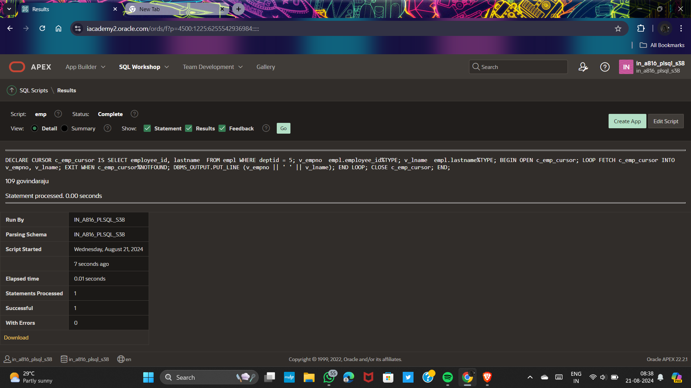

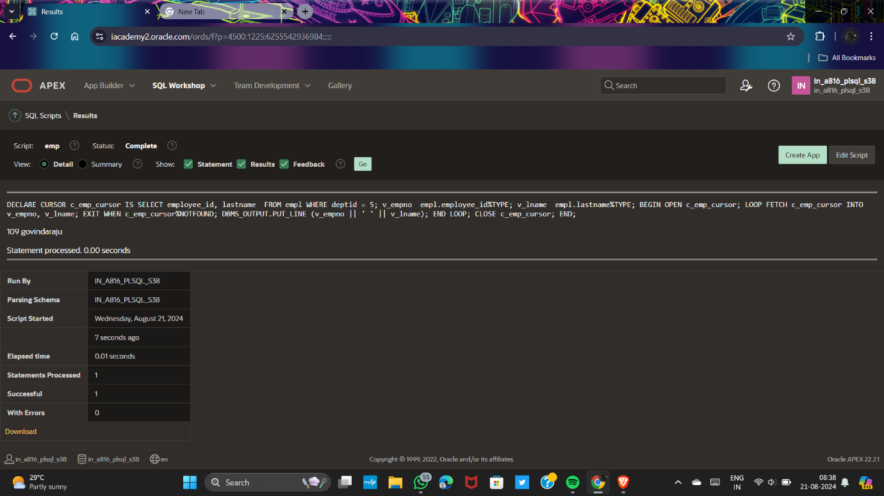

**--Using a cursor FOR loop**

DECLARE

CURSOR c_emp_cursor IS

SELECT employee_id, lastname

FROM empl

WHERE deptid = 2;

BEGIN

FOR emp_record IN c_emp_cursor

LOOP

DBMS_OUTPUT.PUT_LINE (emp_record.employee_id || ' ' ||emp_record.lastname);

END LOOP;

END;

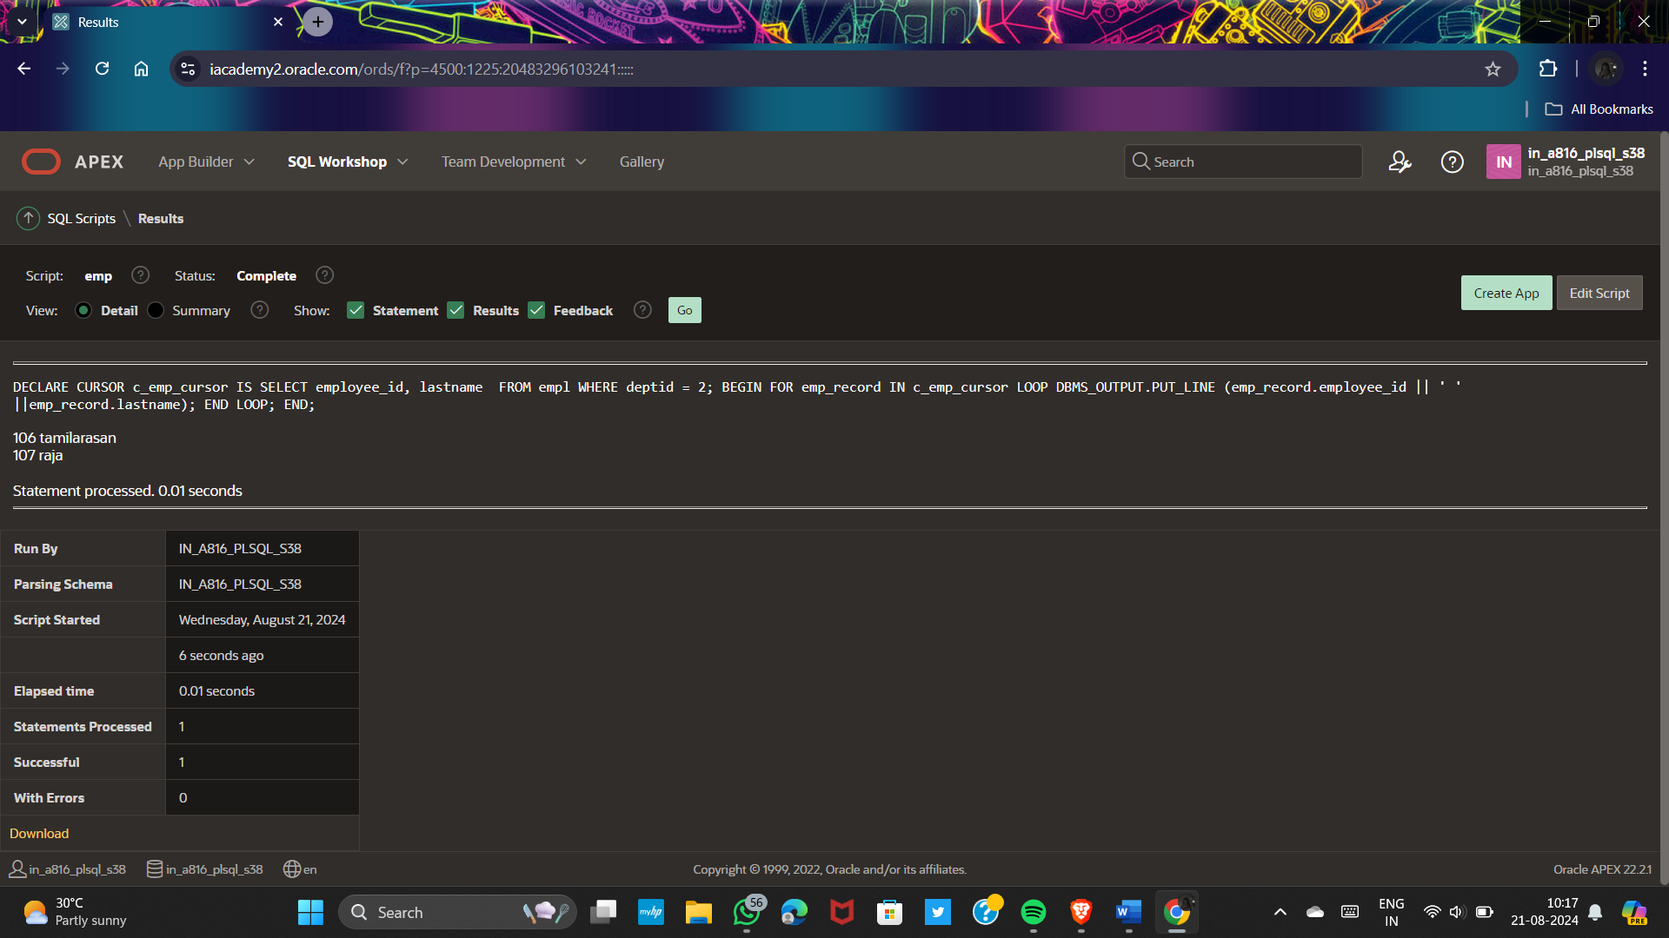

**COMMIT:**

CREATE TABLE pairtable (

column1 INT,

column2 INT

);

BEGIN

INSERT INTO pairtable (column1, column2) VALUES (1, 2);

COMMIT;

END;

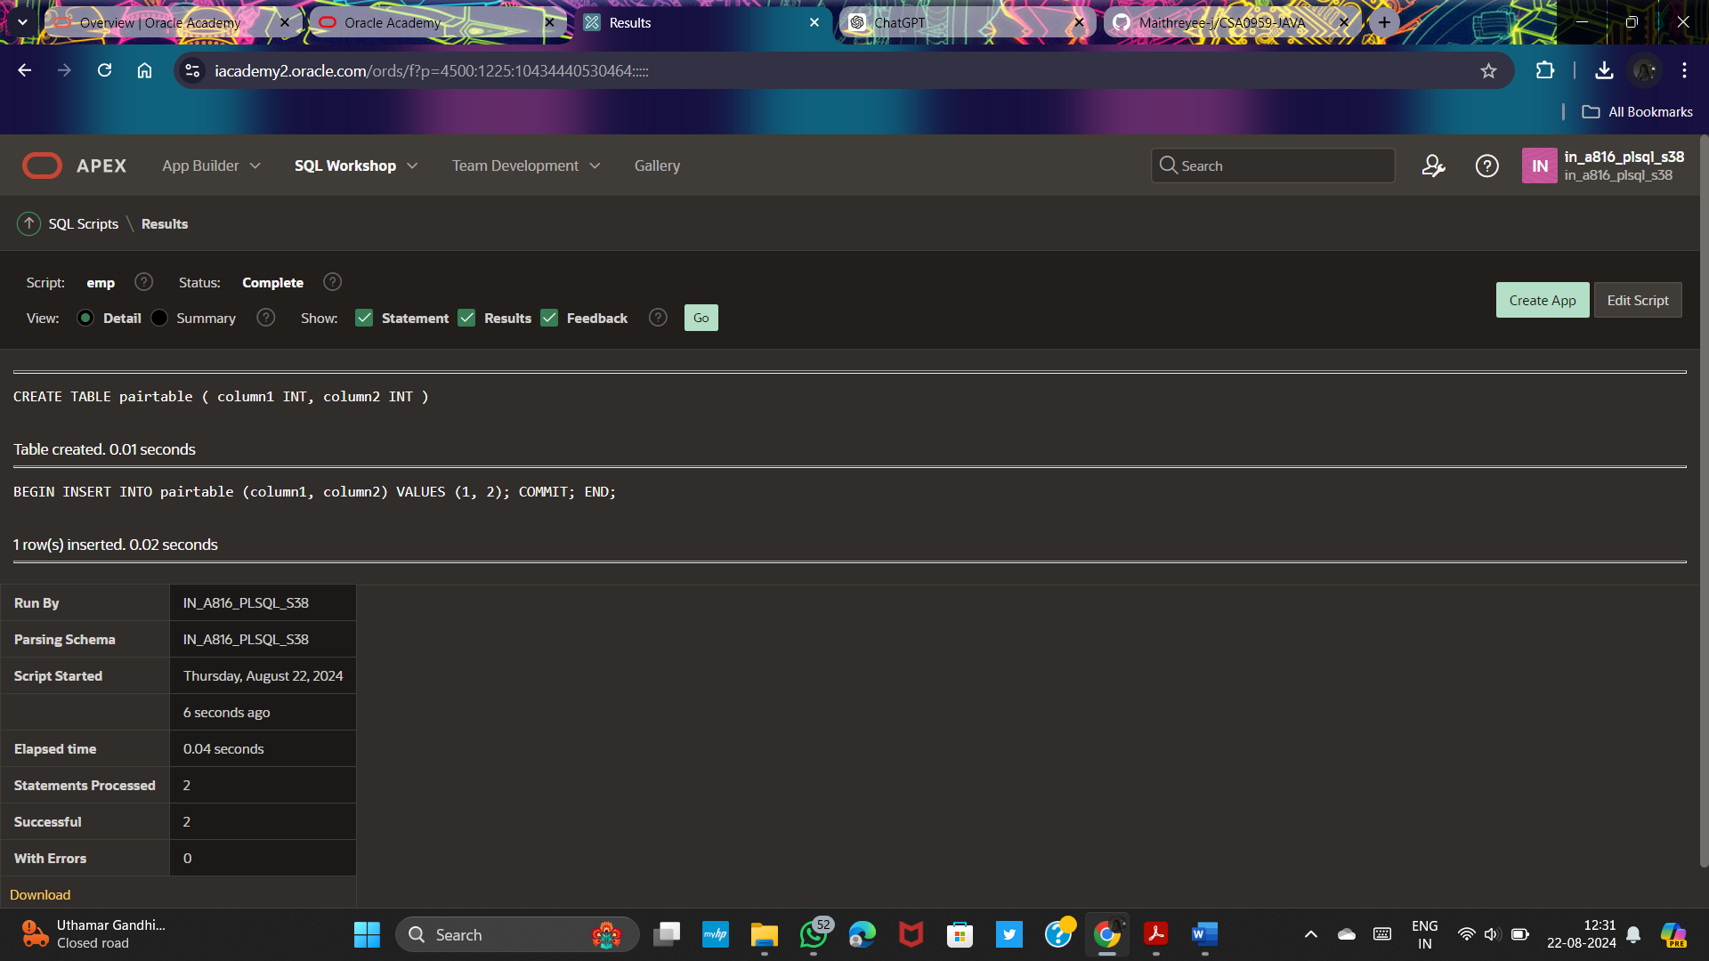

**ROLLBACK:**

BEGIN

INSERT INTO pairtable VALUES (3, 4);

ROLLBACK;

INSERT INTO pairtable VALUES (5, 6);

COMMIT;

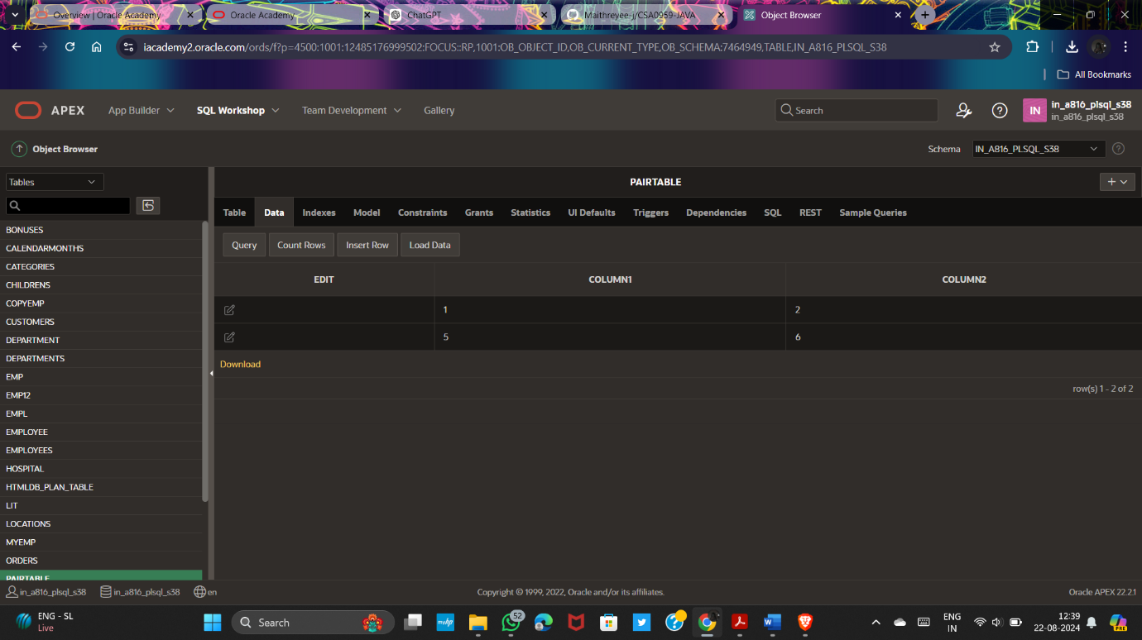

**SAVEPOINT:**

BEGIN

INSERT INTO pairtable VALUES (7, 8);

SAVEPOINT my_sp_1;

INSERT INTO pairtable VALUES (9, 10);

SAVEPOINT my_sp_2;

INSERT INTO pairtable VALUES (11, 12);

ROLLBACK to my_sp_1;

INSERT INTO pairtable VALUES (13, 14);

COMMIT;

END;

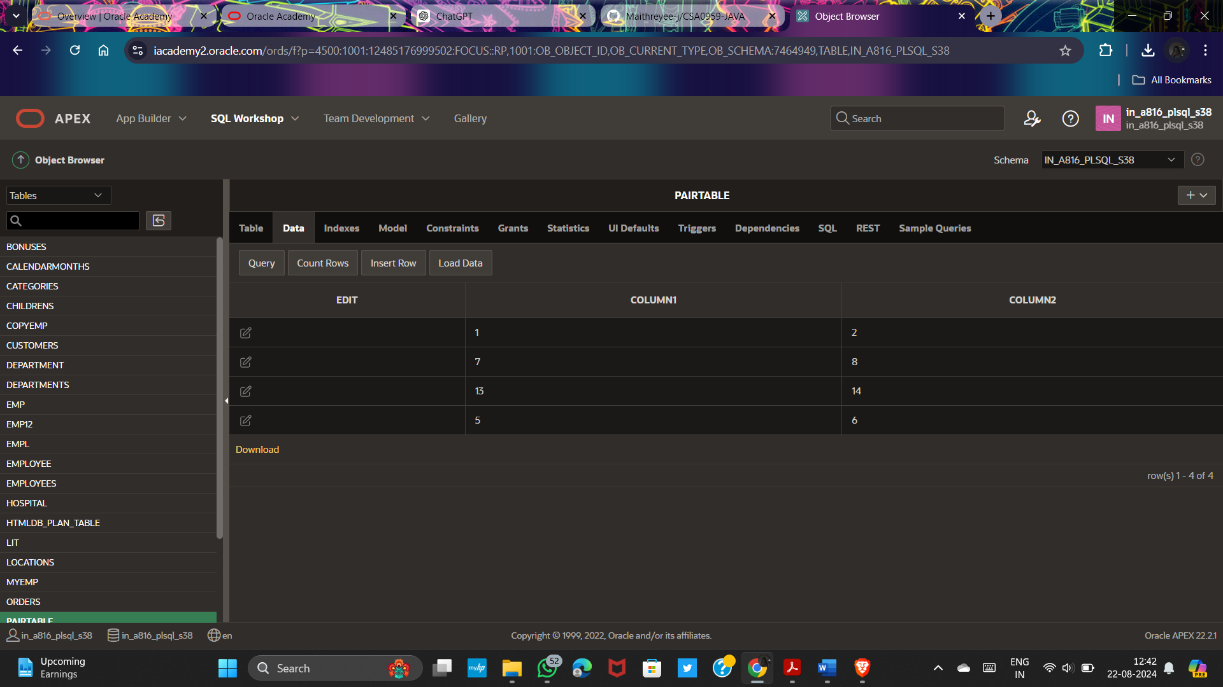

DECLARE

CURSOR person_cursor IS

SELECT id, name, birthdate

FROM persons

ORDER BY birthdate ASC;

v_id persons.id%TYPE;

v_name persons.name%TYPE;

v_birthdate persons.birthdate%TYPE;

BEGIN

OPEN person_cursor;

LOOP

FETCH person_cursor INTO v_id, v_name, v_birthdate;

EXIT WHEN person_cursor%NOTFOUND;

DBMS_OUTPUT.PUT_LINE('ID: ' || v_id || ', Name: ' || v_name || ', Birthdate: ' || TO_CHAR(v_birthdate, 'YYYY-MM-DD'));

END LOOP;

CLOSE person_cursor;

END;

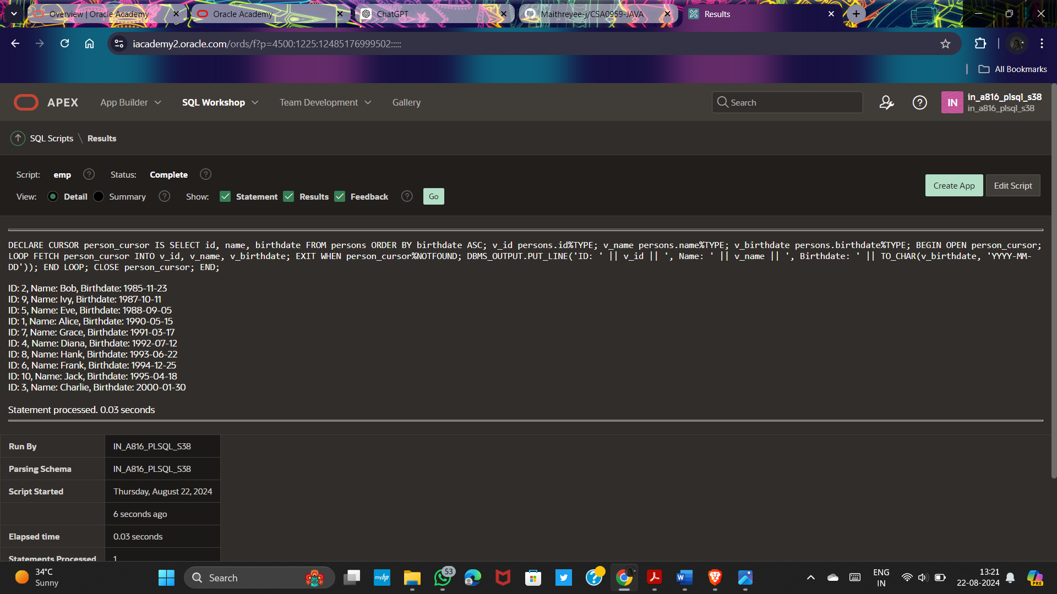

**Using the FORALL statement with SQL%BULK_ROWCOUNT:**

CREATE TABLE NUMTABLE(N NUMBER(20));

DECLARE

TYPE num_list_type IS TABLE OF NUMBER INDEX BY BINARY_INTEGER;

v_nums num_list_type;

BEGIN

v_nums(1) := 1;

v_nums(2) := 3;

v_nums(3) := 5;

v_nums(4) := 7;

v_nums(5) := 11;

FORALL i IN v_nums.FIRST .. v_nums.LAST

INSERT INTO numtable (n) VALUES (v_nums(i));

FOR i IN v_nums.FIRST .. v_nums.LAST

LOOP

DBMS_OUTPUT.PUT_LINE('Inserted ' || SQL%BULK_ROWCOUNT(i) || ' row(s) on iteration ' || i);

END LOOP;

END;

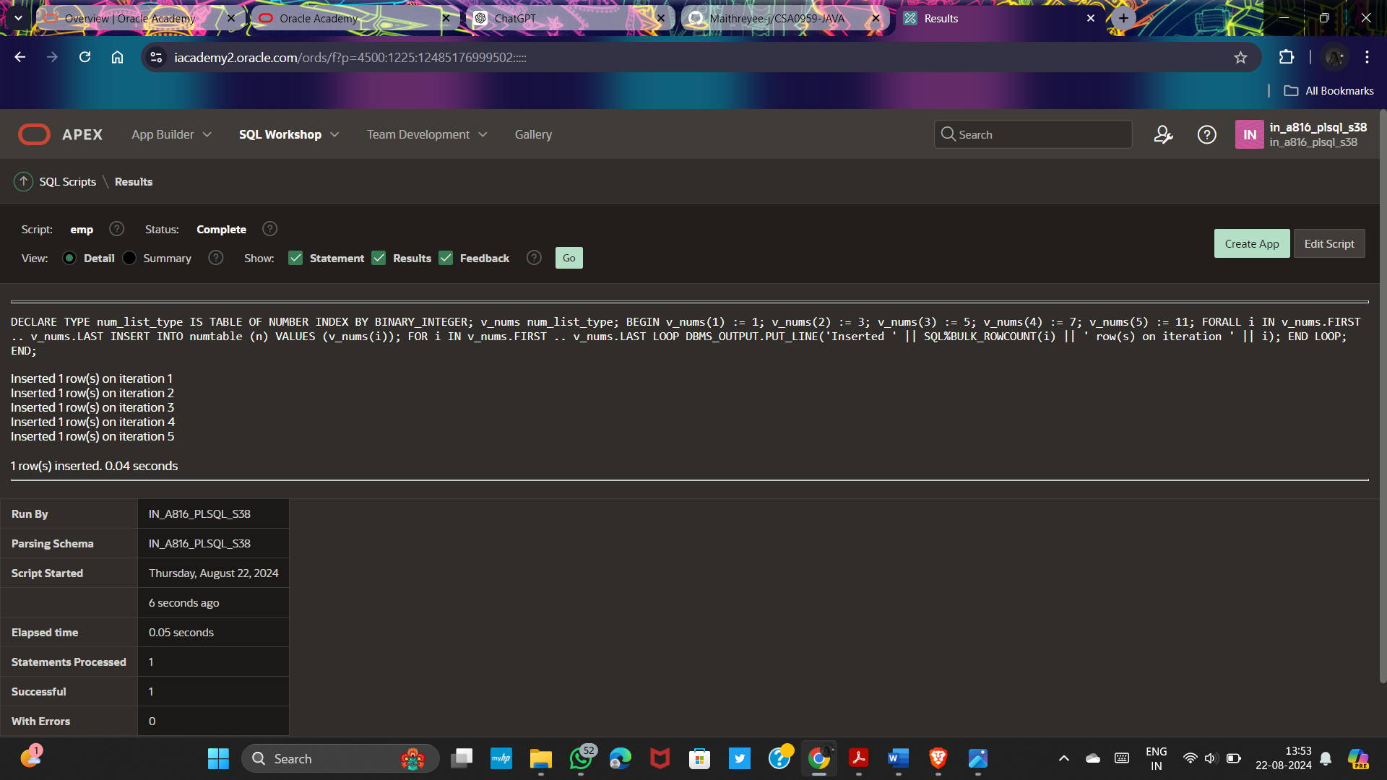

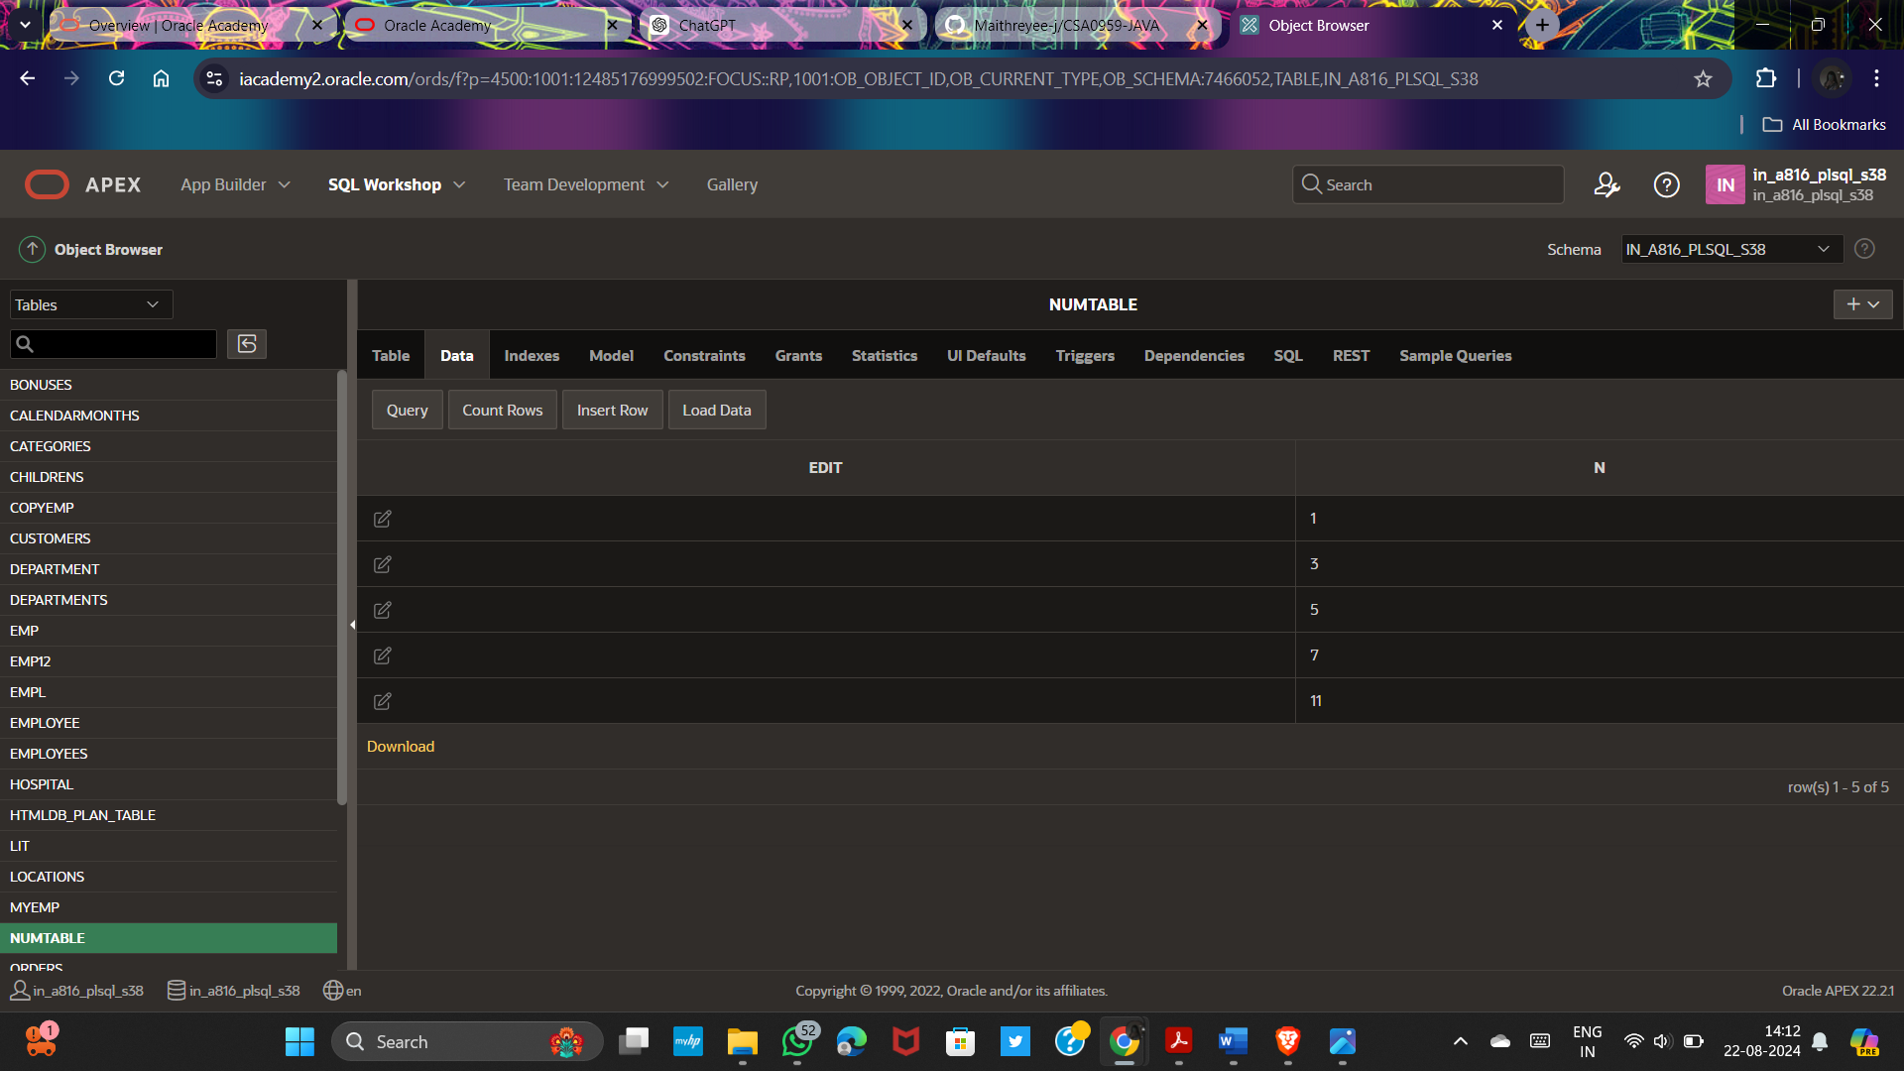

**Example of PL/SQL GOTO statement:**

DECLARE

a number(2):=20;

BEGIN

<<loopstart>>

WHILE a < 50 LOOP

dbms_output.put_line('value of a: '|| a);

a:=a+1;

IF a=35 THEN

a:=a+1;

GOTO loopstart;

END IF;

END LOOP;

END;

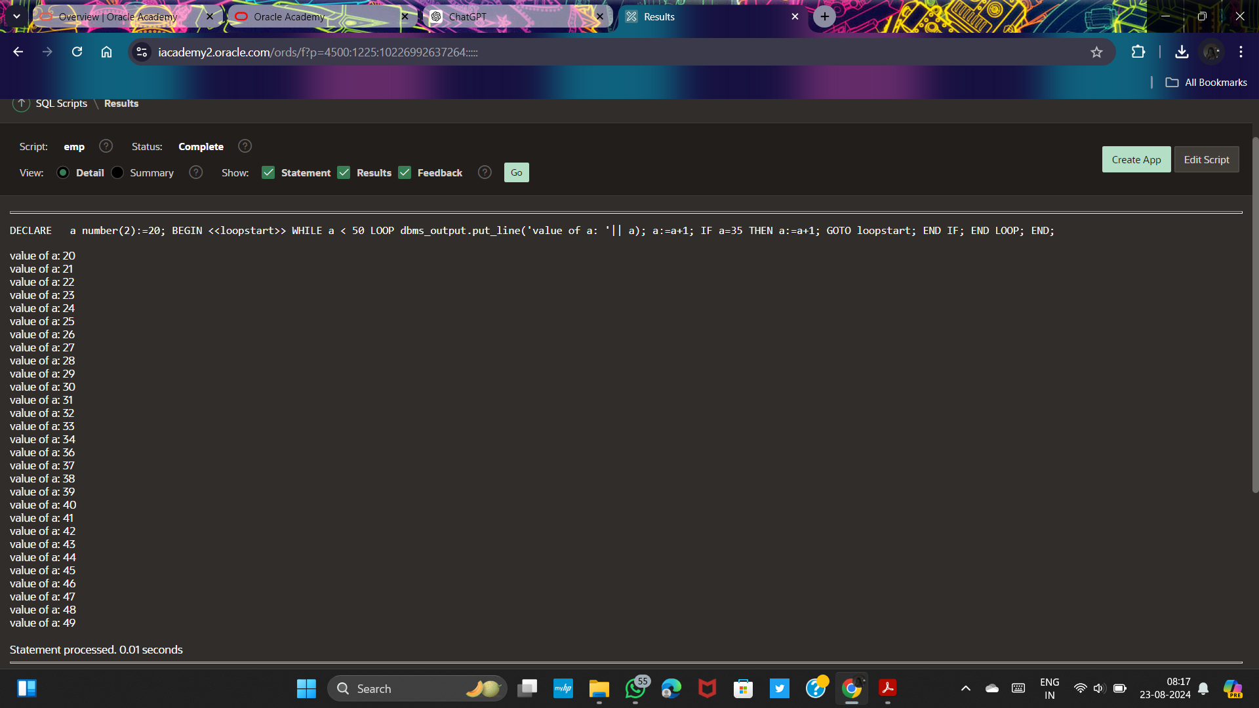

**Write a PL/SQL block to handle the exception when a division by zero occurs:**

DECLARE

dividend NUMBER := 10;

divisor NUMBER := 0;

result NUMBER;

BEGIN

result := dividend / divisor;

DBMS_OUTPUT.PUT_LINE('Result: ' || result);

EXCEPTION

WHEN ZERO_DIVIDE THEN

DBMS_OUTPUT.PUT_LINE('Error: Division by zero');

END;

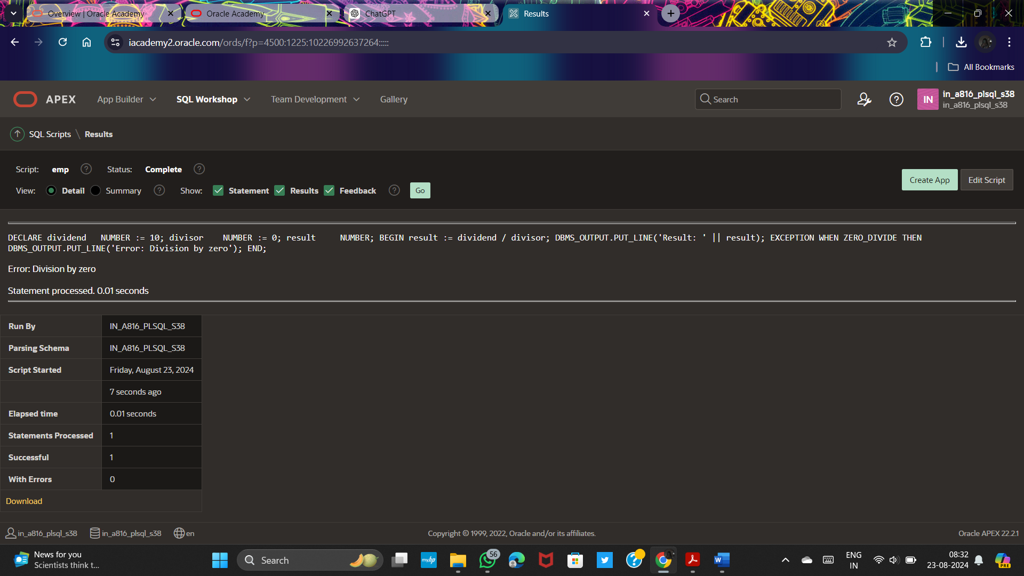

**Handle the NO_DATA_FOUND exception when retrieving a row from a table and no matching record is found:**

DECLARE

emp_name VARCHAR2(100);

emp_id NUMBER := 225;

BEGIN

SELECT firstname INTO emp_name

FROM empl

WHERE employee_id = emp_id;

DBMS_OUTPUT.PUT_LINE('Employee Name: ' || emp_name);

EXCEPTION

WHEN NO_DATA_FOUND THEN

DBMS_OUTPUT.PUT_LINE('Error: No matching record found');

END;

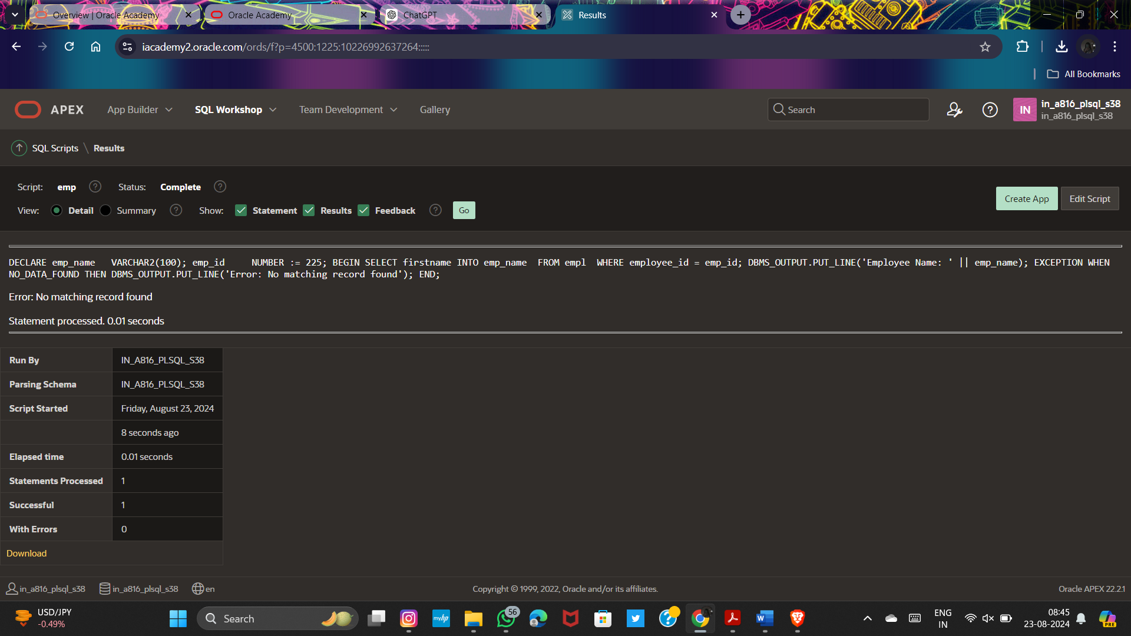

**Handle the TOO_MANY_ROWS exception when retrieving multiple rows instead of a single row from a table:**

DECLARE

v_dep_id worker.department_id%TYPE := 70;

v_emp_id worker.employee_id%TYPE;

v_emp_name worker.first_name%TYPE;

v_emp_salary worker.salary%TYPE;

v_exception_msg VARCHAR2(200);

BEGIN

SELECT first_name, department_id, salary

INTO v_emp_name,v_dep_id, v_emp_salary

FROM worker

WHERE department_id = v_dep_id;

EXCEPTION

WHEN TOO_MANY_ROWS THEN

v_exception_msg := 'Multiple rows found for the given department ID: ' || v_dep_id;

DBMS_OUTPUT.PUT_LINE(v_exception_msg);

WHEN OTHERS THEN

v_exception_msg := 'An error occurred: ' || SQLERRM;

DBMS_OUTPUT.PUT_LINE(v_exception_msg);

END;

